This version represents the final unedited version accepted at Nature Human Behaviour.

Domain-Generality is an Emergent, not Inherent, Property of Metacognition

Carolyn Baer*, Trent University and University of British Columbia, ORCID: 0000-0003-4521-8006
Simona Ghetti, University of California, Davis, ORCID: 0000-0001-8282-0616
Darko Odic, University of British Columbia, ORCID: 0000-0001-5783-2789

*Corresponding author: carolynbaer@trentu.ca

Abstract
We experience some level of confidence in all decisions we make, yet our understanding of how confidence is generated remains elusive. Here, we examine three potential aspects of metacognitive confidence judgments that could be similar across the distinct domains of memory and perception in adults (N = 236) and children (aged 4-7 years, N = 263; 122 girls and 141 boys) from Vancouver, Canada. Using episodic memory and perceptual tasks, we reveal that while confidence bias correlates across domains at all ages, confidence sensitivity and efficiency are both distinct. Crucially, children aged 6 and older can flexibly contrast confidence states across memory and perceptual decisions, indicating a shared internal metric of confidence. In contrast, 4-5-year-old children struggle with cross-domain comparisons, highlighting a developmental transition in metacognitive processing. Overall, findings highlight the distinct yet commensurable nature of memory and perceptual confidence, with domain-general processes emerging by age 6.

Code Availability: The code used to present stimuli to participants and to analyze data are available on the Open Science Framework at https://osf.io/hf6xj/.

Acknowledgements: This work was funded by the Social Sciences and Humanities Research Council of Canada through an Insight Development Grant (to D.O.), a Canada Graduate Scholarship (to C.B.) and Postdoctoral Fellowship (to C.B.). The funders had no role in study design, data collection and analysis, decision to publish or preparation of the manuscript. Thanks to Samin Alighanadi, Beatriz Araujo, Leona Cheng, Ashley Choo, Divya Gupta, Nick Fai, Mahnoor Faisal, Eddie Kim, Somi Lim, Stephanie Markovic, Dylan Omejc, Tanya Pardiwalla, Sally Poon, Isabella Schoettler, Eliscia Sinclair, Megan Toi, and Jovita Wiyogo for their assistance with data collection, to CB’s writing groups for feedback on portions of the manuscript, and to all the schools and families for their support.

Author Contributions: CB, SG, and DO all contributed to the conceptualization and design of the studies. CB and DO programmed the experiments. CB coordinated data collection, conducted analyses, and drafted the manuscript. CB, SG, and DO all provided critical edits.

Competing Interests: The authors declare no competing interests.

We experience some level of confidence whenever we make decisions: “I am sure I locked my door,” or “I am not sure I can see the lake in this fog.” Confidence is a valuable signal that alerts us to the reliability of our thoughts ^{1,2}. But the mechanisms that explain how humans estimate and evaluate confidence remain a puzzle for cognitive scientists.
Estimating confidence is a multistep process ^{2–4}. After making a decision, we must first attend to some internal signal that informs us about the reliability of that decision. For example, an individual might have access to the perceptual noise inherent in their representations of the world, and use it to generate confidence ^{5,6}. After finding the relevant signal for the decision, the individual must convert it to a scaled value such as a numeric probability of having made the right decision ^{2,7}. Evidence for scaling can be found, for example, in findings that integrating multiple sensory signals is relativized by the confidence in each ⁸. Finally, if asked to externalize confidence (e.g., in words, or on a Likert scale), this value must be converted into a categorical response, such claiming that we are “very confident,” or we feel “unsure”. See Figure 1 for a visual depiction.

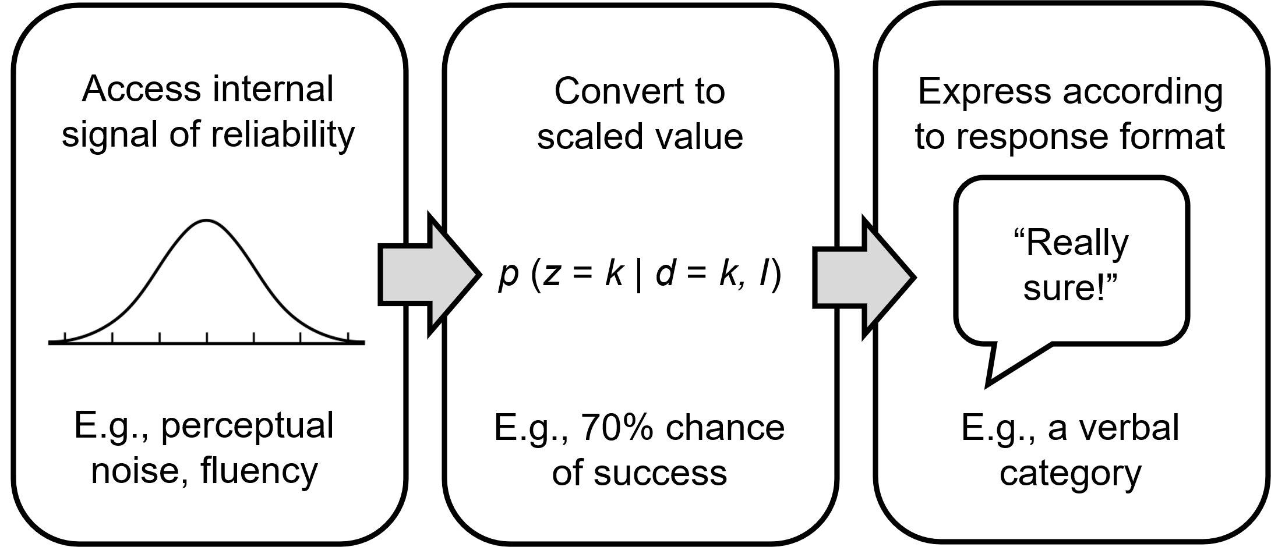

Figure 1. The multistep process of estimating confidence.
Internal signals of the reliability of a decision (e.g., perceptual noise, fluency, etc.) are stored as a scaled value (e.g., a probability of being correct, self-consistency), that is then interpreted relative to the required response format. The formula in box 2 is adapted from Pouget et al. ², which computes the probability that the decision was correct (z = k), given that the observer chose option k based on the input I.

Something akin to this process exists for every decision we make: we estimate confidence when deciding how many things we see ^{9,10}, how well we remember something ¹¹, what food we value more ¹², and more. Is “confidence” a singular, general process across domains (e.g., perception and memory), or is it estimated through mechanisms that differ across cognitive domains? One possibility is that confidence is singular: we might attend to similar internal signals, estimate them as identical units, and externalize them equally well no matter what type of decision we are making. Alternatively, some or all parts of this process might work distinctly across domains ^{13,14}. For example, we might attend to very different signals for memory versus perception, use different units for each, or believe that we are poor at memory but excellent at perception even when our skill level is actually equivalent. Memory and perception are two especially popular domains for comparing confidence because of the long history of investigation in each of them ^{10,15}.
To study similarities and differences across domains of confidence, researchers primarily rely on correlations in three individual difference measures of confidence ^{13,16–19}. Confidence sensitivity refers to how well individuals’ confidence can distinguish between their correct and incorrect decisions, potentially telling apart even the smallest differences in signal quality between these types of decision situations. Confidence efficiency expands this idea by correcting confidence sensitivity for actual task accuracy, yielding a metric of how informative confidence is given one’s performance level. To illustrate this point, imagine one individual who performs well on a task and reports higher confidence on correct answers than incorrect answers (good sensitivity), and a second individual who performs poorly on a task but still reports higher confidence on correct answers than incorrect answers. This second individual would have higher confidence efficiency because they managed to demonstrate good sensitivity despite having less reliable information to work with. Confidence bias, on the other hand, is about individual differences in the externalization process, where some people may consistently claim to be over-confident even given poor internal signals ²⁰.
If confidence is a singular domain, we should expect that sensitivity, efficiency, and/or bias show strong correlations across domains, since any imprecision in the confidence extraction and reporting process will yield correlated individual differences across domains. But the evidence for confidence as a singular domain is not that straightforward. Correlations in sensitivity, efficiency, and bias are almost always found between confidence estimates in distinct perceptual tasks ¹⁹, such as when participants judge the contrast versus the orientation of Gabor patches ²¹ (see also ²² for similar evidence within distinct memory tasks). But correlations across domains like memory and perception are inconsistent and small, generally showing common metacognitive bias but not sensitivity or efficiency in these domains ^{13,17,18}. This is convergent with neuropsychological dissociations for brain regions supporting confidence for memory versus perception ^{23,24}. This might suggest that confidence for memory versus perception are distinct processes with some distinct individual difference signatures, perhaps stemming from different access to uncertainty signals for the two.
A second approach is to look for commensurability of confidence across domains ^{9,25,26}. This approach is especially good for identifying if confidence is represented with identical units (e.g., probability of being correct), or if each domain is scaled according to its own rules and with distinct units. If confidence is represented as a general factor across domains, then it should also be easily comparable: observers should be able to say whether they are more confident in their memory or their perceptual decision ²⁶. In fact, if the two domains are on a truly single general scale, we should be just as good at comparing confidence between two perceptual decisions as we are comparing a perceptual to a memory decision. On the other hand, if confidence is represented on entirely separable scales using domain-specific units, then comparison would be impossible (or at least imprecise or time-consuming given the need to further “translate” into a common metric). Mirroring correlations, the commensurability approach has broadly shown evidence for a general sense of confidence for different perceptual decisions, e.g., visual versus auditory ^{25–28}. However, this has not yet been extended to domains outside of perception.
In the current work, we address two gaps in the current research on the structure of confidence across domains. First, we investigate the possibility that the structure of confidence changes over development, inspired by findings that children’s intellectual abilities differentiate with development ^{29,30}, while other competencies like their number comparison abilities integrate ³¹. The currently limited correlational work in children’s confidence reasoning already points towards some developmental change. Children younger than 8 show no correlations for sensitivity or bias across domains, even within perceptual decision-making ^{32–36}. But, by 9-11 years old, they do ^{33,34}. This pattern suggests that confidence may become more generalized with age, akin to number representations. Studies of confidence commensurability in childhood are even rarer, with one study showing commensurability of perceptual confidence in 6-8 year-olds ³⁷, but no study has compared memory to perception.
Second, we examine the relation between perceptual and memory confidence using both the correlational and the commensurability approaches. Beyond providing additional data on currently mixed correlational findings for these domains, our work interrogates memory and perception using the commensurability approach in adults and children, allowing us to examine if perceptual and memory confidence are represented using identical units on a general scale.
In Experiment 1, we use the correlational approach with episodic memory and area perception in both 5-7-year-old children and undergraduate students, focusing on correlations in confidence sensitivity, efficiency, and bias. In the episodic memory task, participants saw a series of images and were asked to identify those images when paired with similar distractors. In the perception task, participants indicated which of two amorphous shapes was bigger. Following each trial of both the memory and perception tasks, participants made a metacognitive assessment of their confidence using a 3-point scale. See Figure 2 for an overview of the materials. We find no correlations in sensitivity or efficiency between these domains at any age, but find strong correlations in bias. These results suggest that the signals children and adults attend to in order to estimate confidence are distinct for memory and perception across age.
In Experiment 2, we use the commensurability approach with the same domains and age groups. Instead of assessing confidence on a 3-point scale as in Experiment 1, here we instructed participants to select which of two decisions was subjectively experienced as more accurate than the other ^{25,26,38,39} (see Figure 3). Previous research has shown that these choices are guided by subjective confidence even in preschool children ⁴⁰, and the format may reduce

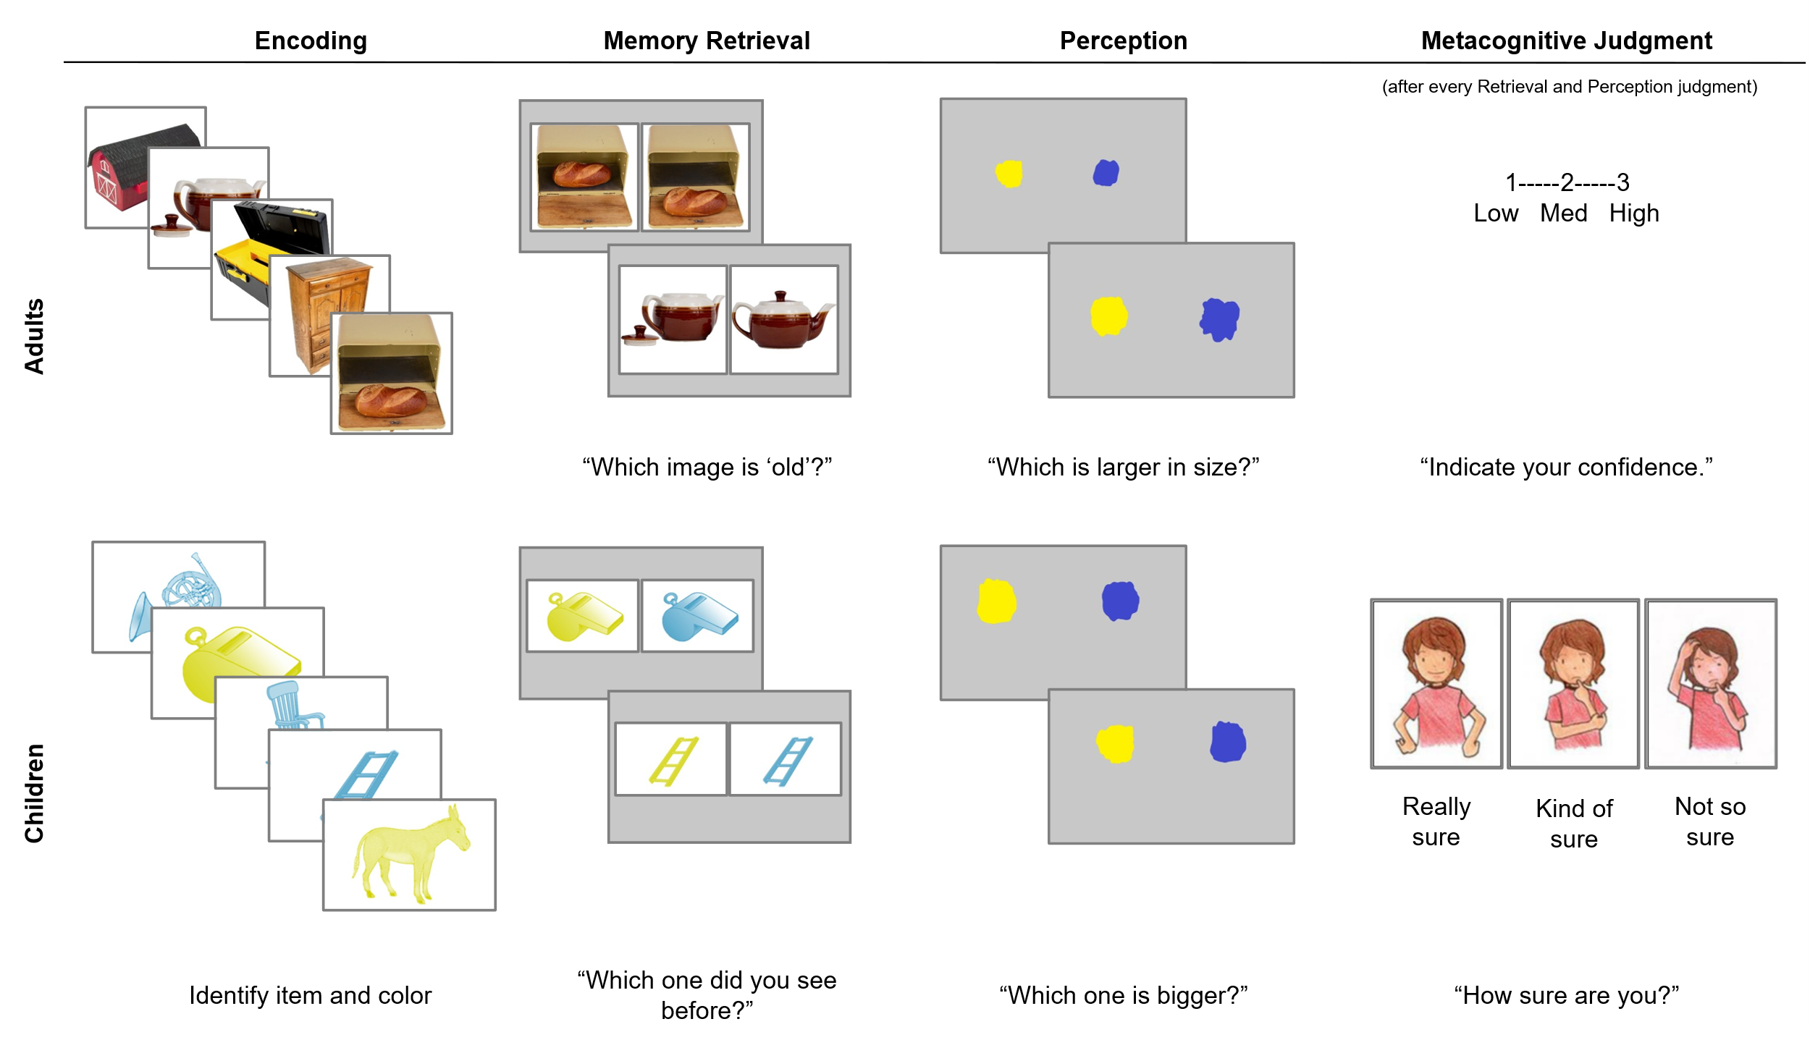 Figure 2: Stimuli used in Experiment 1A (Adults) and 1B (Children).
In the Encoding phase, participants saw items one at a time, and children additionally indicated its identity and colour. In the Retrieval phase, participants identified the item they saw during Encoding from a similar distractor. In the Perception task, participants indicated which shape was bigger. Following every Memory and Perceptual judgment, participants gave a confidence judgment on a three-point scale. Memory and Perception sections were counterbalanced across participants.

working memory demands. This paradigm requires that participants compare the experience of confidence in each trial directly against one another. If confidence is represented on a domain-specific scale, such comparisons should only be possible or cost-free when both decisions are from the same domain (e.g.,Memory vs Memory). If confidence is instead represented in a domain-general format, such comparisons should be possible and not incur additional costs even when comparing across domains (e.g., Perception vs Memory). To assess whether their confidence decisions were warranted, we examined whether participants were more accurate on Chosen trials (i.e., those participants were more confident of) than Discarded trials ³⁹. On half of the trials, the two decisions were drawn from different domains (Perception and Memory, ‘Across-Domain Condition’), allowing us to test whether participants could compare their confidence across domain boundaries. On the other half, the two decisions were drawn from the same domain (e.g., Perception and Perception, ‘Within-Domain Condition’), which served as a within-subjects control. In contrast to Experiment 1, we find that children from age 6 and adults can compare memory and perceptual confidence without any accuracy cost, suggesting generality in how confidence is converted to a scaled value.

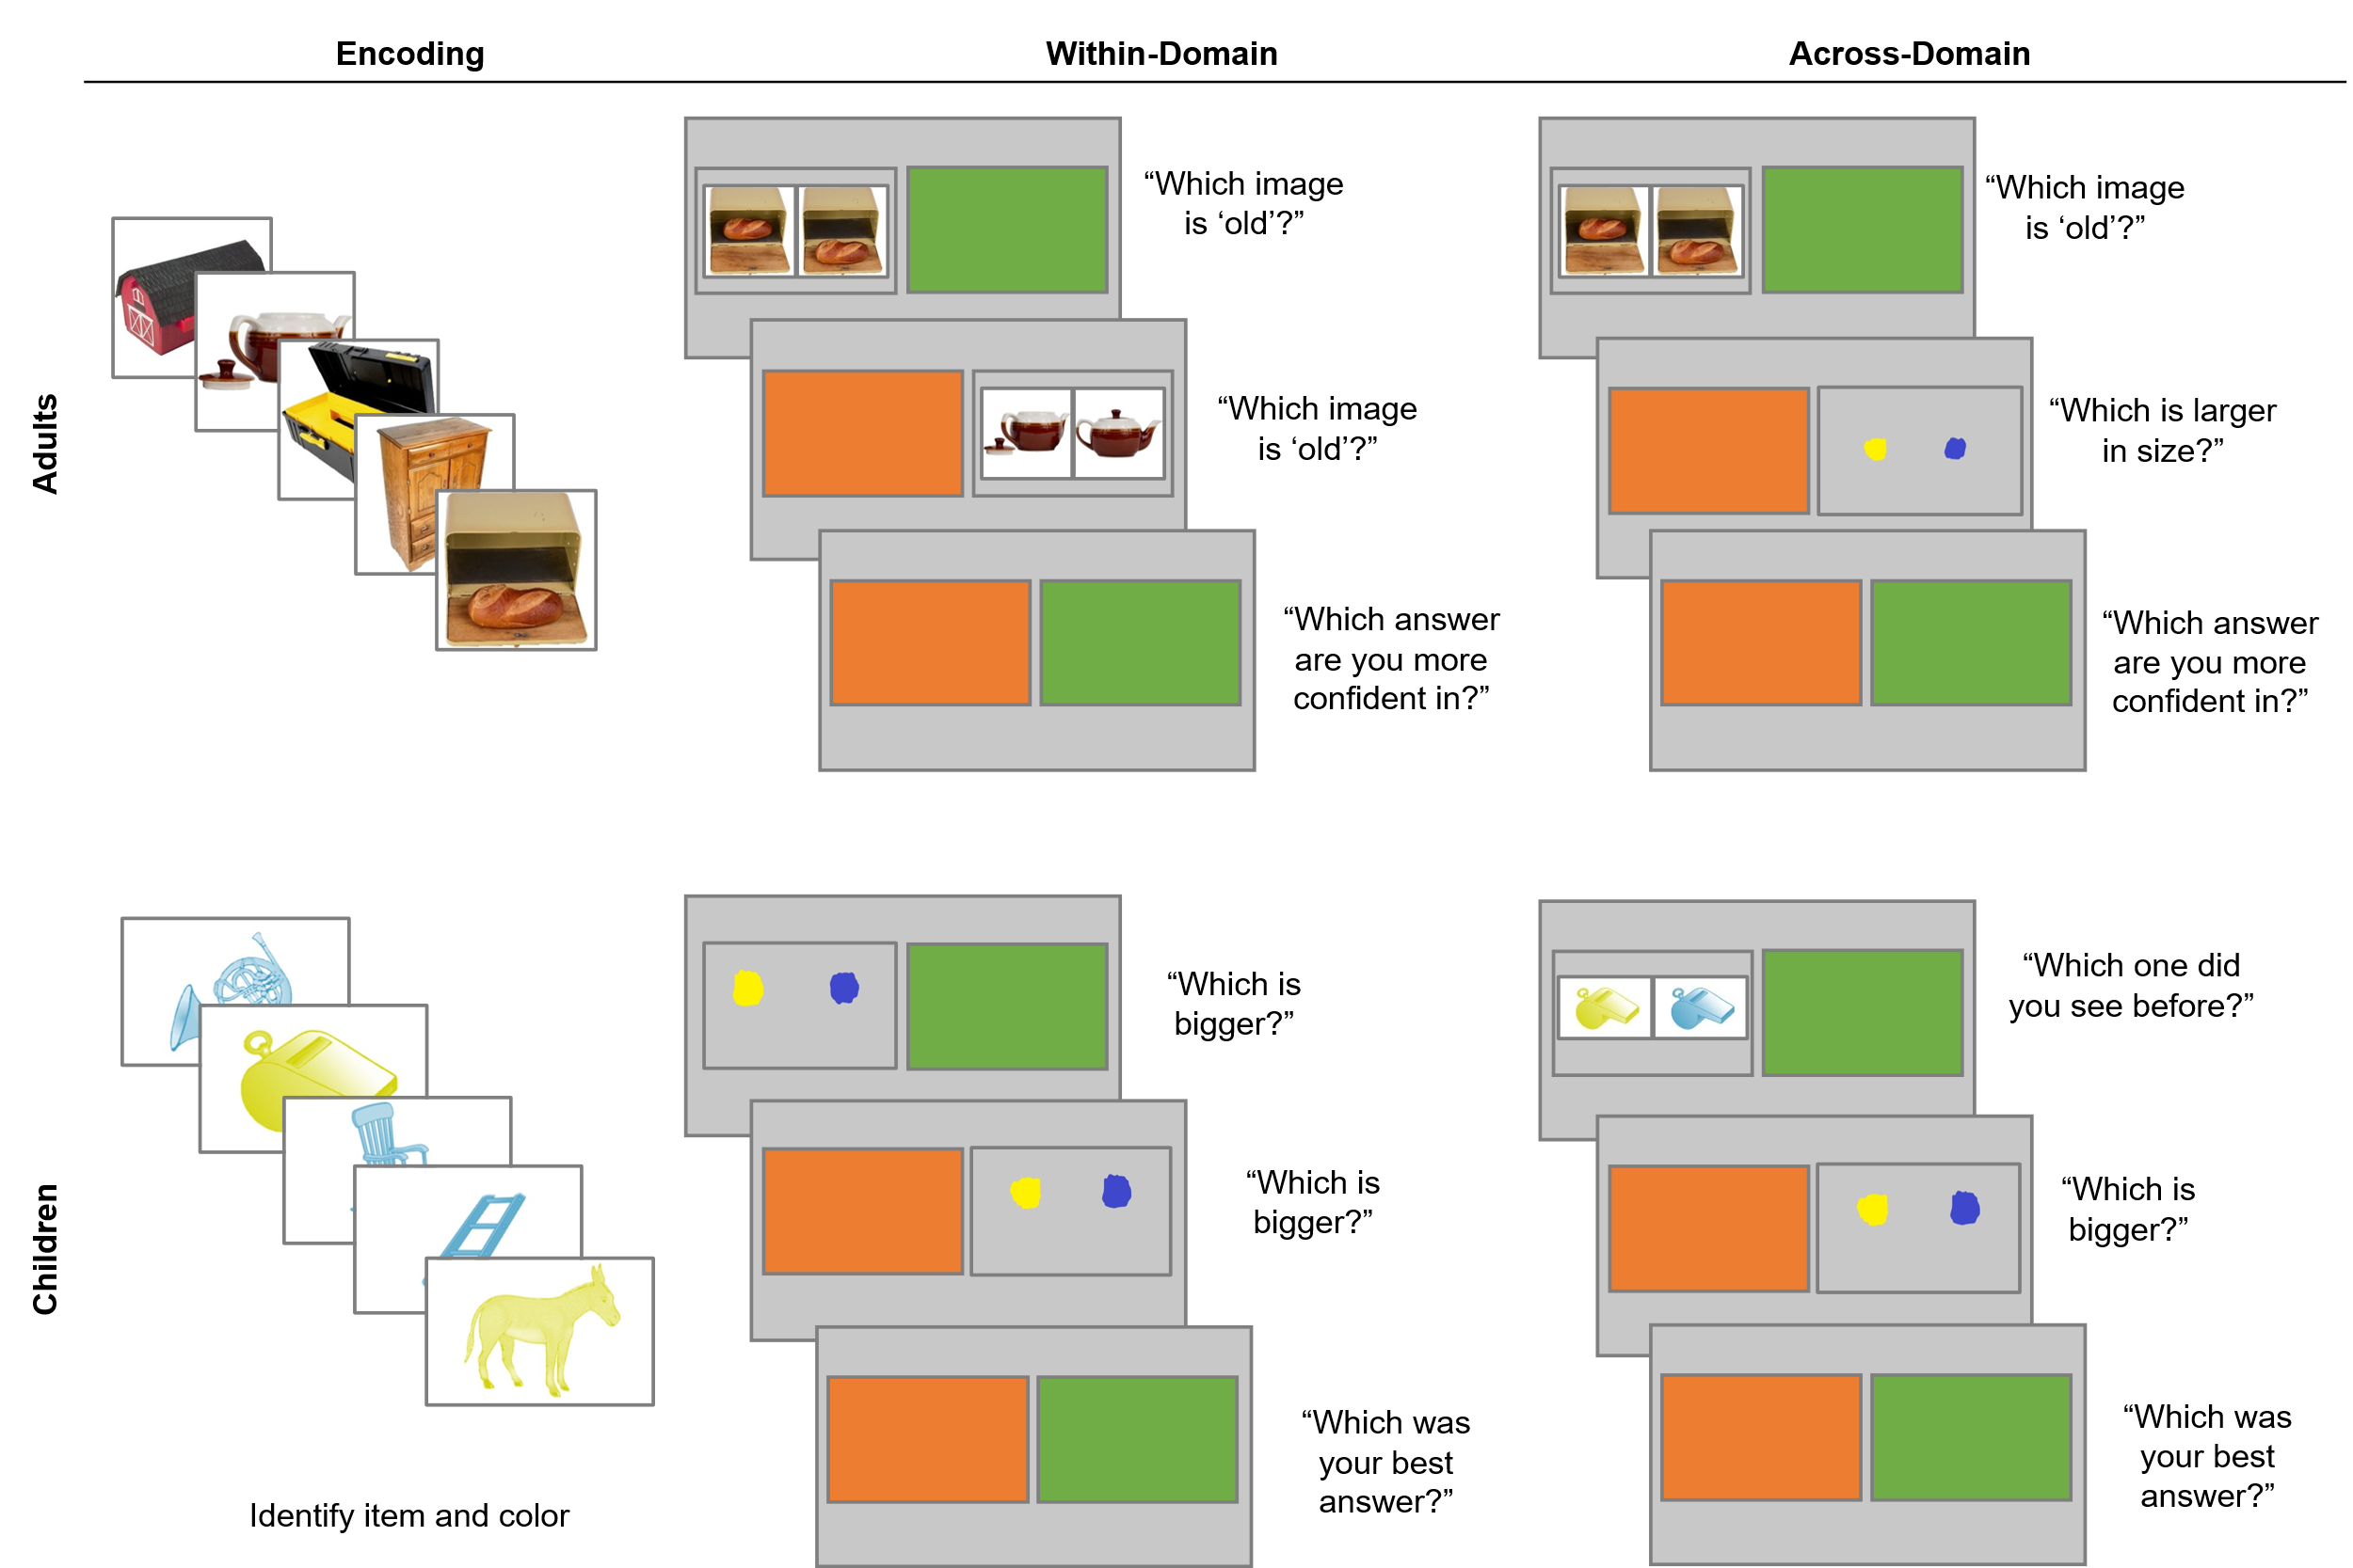

Figure 3. Stimuli used in Experiment 2A (Adults) and 2B (Children).
On Within-Domain trials, participants answered two questions from the same domain (Perception or Memory), then indicated which answer they were most confident in. In Across-Domain trials, participants answered one question from each domain.

Results

Experiments 1A (Adults) and 1B (Children)

Memory and Perceptual Accuracy
Accuracy scores were correlated between the Memory and Perceptual tasks for adults (N = 129), Spearman’s ρ(127) = .26, p = .003, 95% CI = [0.08, 0.42], BF₁₀ = 8.19, but not for 5-7-year-old children (N = 131; controlling for age), Spearman’s ρ(128) = -.03, p = 1.000, 95% CI = [-0.21, 0.15], BF₁₀ = 0.12 (see Figure 4). See Table 1 for means and standard deviations. We preregistered conducting this analysis separately for younger and older participants due to stimulus differences, but deviated from our preregistration as we had to exclude 4-year-olds from the sample (see Methods). The values do not change in direction or magnitude when analyzed as preregistered (see Preregistered Accuracy Correlations in the Supplemental Information). These correlations set a baseline for interpreting subsequent analyses of metacognitive measures, expecting that any similarities in metacognitive reasoning would yield stronger results.

Confirmation of Metacognitive Abilities in Children
We confirmed that children’s confidence was higher for correct than incorrect answers through separate 2 (Trial accuracy: Correct, Incorrect) by 3 (Age: 5, 6, 7) mixed ANOVAs on Confidence choices (3 = high confidence, 2 = medium confidence, 1 = low confidence) in each task. For this analysis, we included all children who completed that task (n = 154

Experiment 1A & 1B
Measure | Age | Memory |  | Perception
Task Performance |  | Accuracy | SD | Accuracy | SD
 | Adults | 73% | 7% | 86% | 8%
 | Children | 68% | 8% | 70% | 9%
Metacognitive Sensitivity |  | Meta-d' | SD | Meta-d' | SD
 | Adults | 1.45 | 0.57 | 1.05 | 0.69
 | Children | 0.74 | 0.78 | 0.78 | 0.74
Metacognitive Efficiency |  | MRatio | SD | MRatio | SD
 | Adults | 1.25 | 0.49 | 0.53 | 0.36
 | Children | 0.89 | 1.20 | 0.83 | 0.98
Metacognitive Bias |  | Bias | SD | Bias | SD
 | Adults | 5.49 | 7.16 | -9.51 | 11.52
 | Children | 25.74 | 9.77 | 24.68 | 10.43
Confidence Rating |  | Confidence | SD | Confidence | SD
 | Adults | 2.14 | 0.23 | 2.06 | 0.33
 | Children | 2.45 | 0.31 | 2.49 | 0.33
Experiment 2A & 2B
Measure | Age | Memory |  | Perception
Task Performance |  | Accuracy | SD | Accuracy | SD
 | Adults | 82% | 11% | 84% | 8%
 | Children | 63% | 12% | 68% | 12%

Table 1. Descriptive statistics in Experiments 1 and 2.
Task performance refers to participants’ accuracy at remembering the correct colour (Memory) or identifying the larger shape (Perception). Metacognitive Sensitivity quantifies how well participants can discriminate accurate from inaccurate answers in their confidence ratings. Metacognitive Efficiency quantifies participants’ sensitivity relative to their task accuracy. Metacognitive Bias is the difference between their average confidence (scaled between 50-100) and their task accuracy. Confidence Rating is the average rating from 1: Low confidence to 3: High confidence.

for Memory and n = 166 for Perception) to maximize power, as preregistered. Children gave higher confidence ratings for correct answers on both the Memory, F(1, 151) = 220.66, p < .001, η_{p}² = 0.59, and Perception tasks, F(1, 163) = 96.97, p < .001, η_{p}² = 0.37, see Figure 5. There was a trend toward an Age by Accuracy interaction in the Memory task, F(2, 151) = 2.90, p = .058, η_{p}² = .04, and a trend for an Age main effect in the Perception task, F(2, 163) = 2.60, p = .078, η_{p}² = .03, but because both of these results failed to reach conventional levels of statistical significance, they are not further interpreted. There were no other effects or interactions with age in either task, ps > .470.

Correlations Between Metacognitive Indices
Metacognitive Sensitivity and Efficiency Adults’ metacognitive sensitivity (meta-d’) ⁴¹ was not significantly correlated across Memory and Perception, Spearman’s ρ(127) = .16, p = .065, 95% CI = [-0.02, 0.33], BF₁₀ = 0.53, nor was their metacognitive efficiency (MRatio), ρ(127) = .02, p = .861, 95% CI = [-0.16, 0.19], BF₁₀ = 0.12. Similarly,
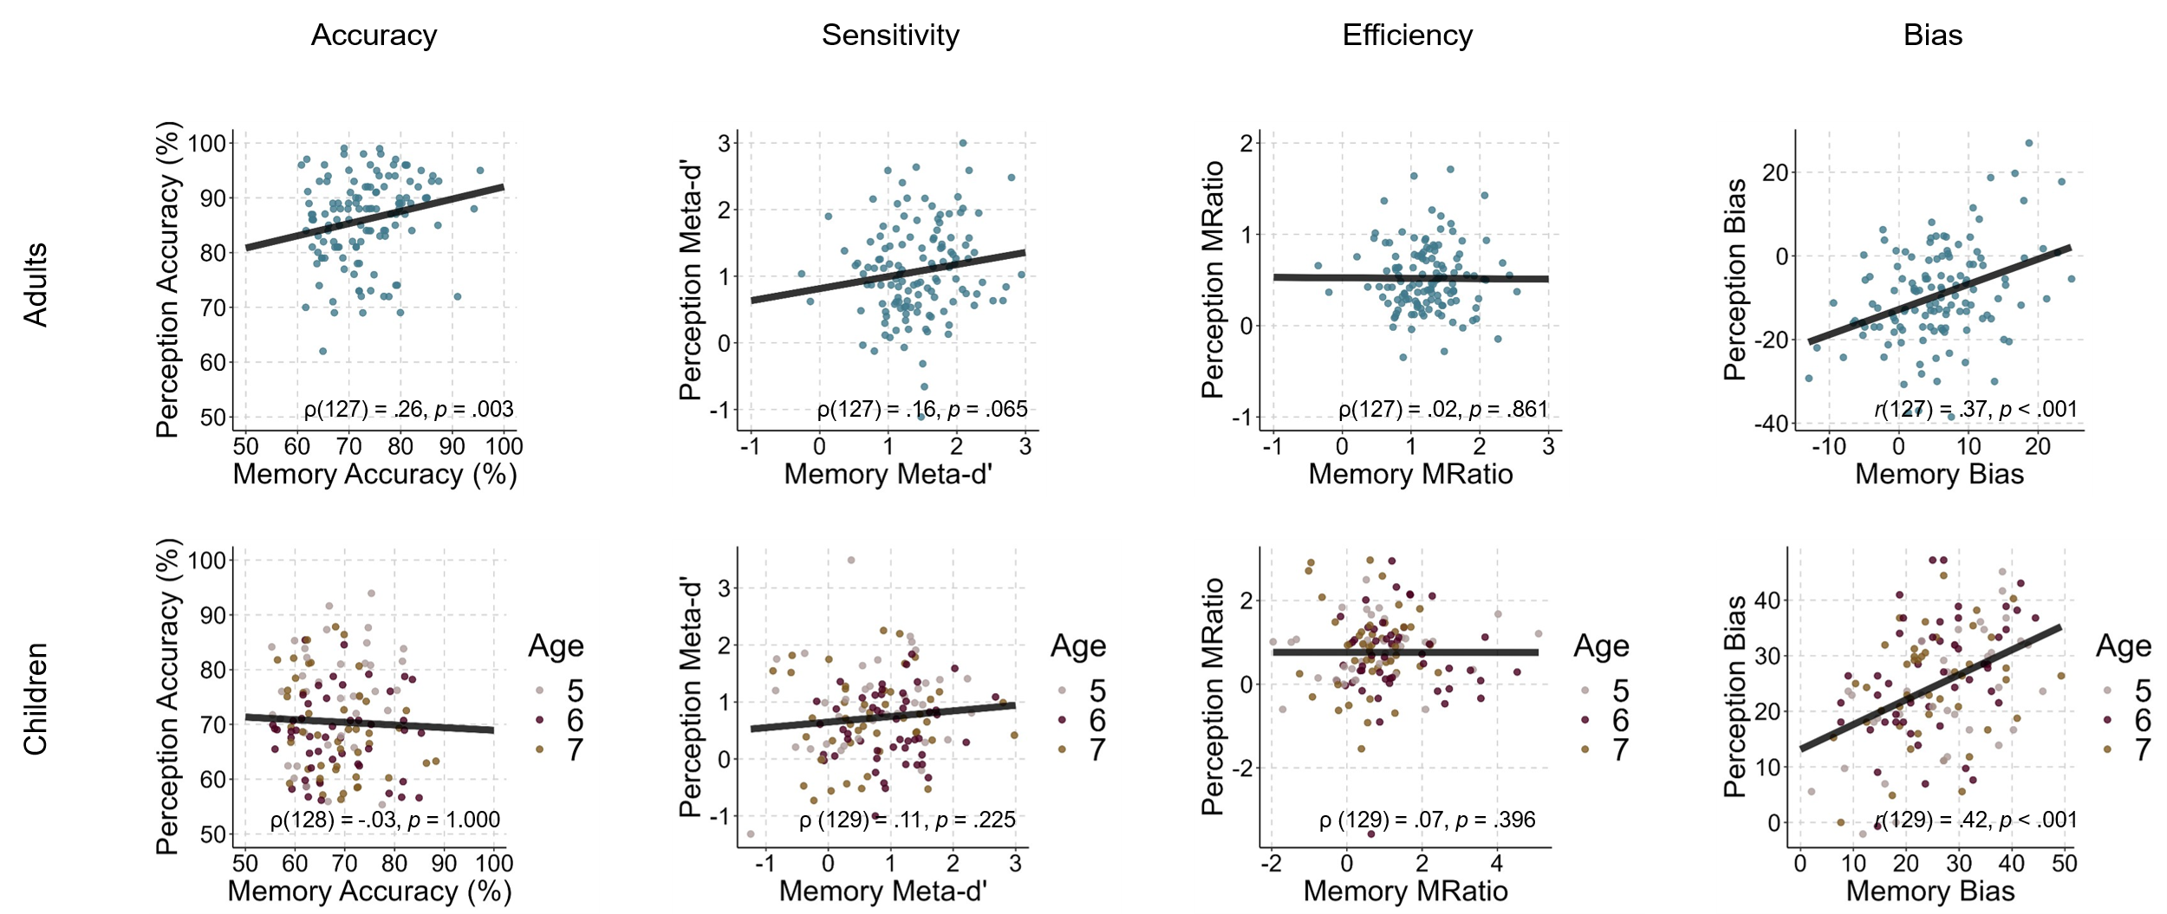

Figure 4. Correlations between dependent variables for Experiment 1A (Adults, N = 129), and 1B (Children, N = 131).
Accuracy refers to remembering the correct colour (Memory) or identifying the larger shape (Perception). Metacognitive Sensitivity quantifies how well participants can discriminate accurate from inaccurate answers in their confidence ratings. Metacognitive Efficiency quantifies participants’ sensitivity relative to their task accuracy. Metacognitive Bias is the difference between their average confidence (scaled between 50-100) and their task accuracy. Pearson’s r and Spearman’s ρ were conducted two-tailed, and we did not adjust for multiple comparisons.

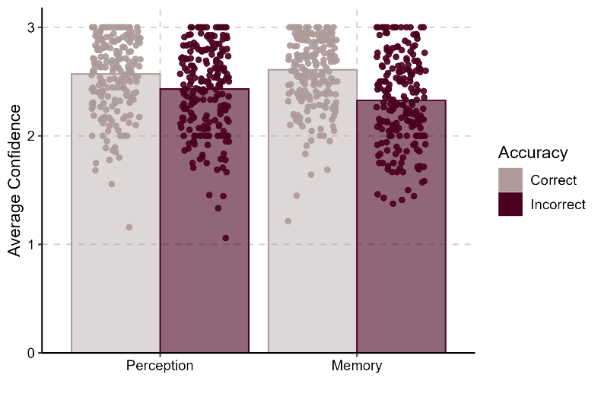
Figure 5. Children’s average confidence by accuracy and task type.
Children’s (N = 131) average confidence when accurate and inaccurate, by task type, from 1: Low confidence to 3: High confidence.

children’s meta-d’ was not correlated across tasks, ρ(129) = .11, p = .225, 95% CI = [-0.07, 0.28], BF₁₀ = 0.27, nor was their MRatio, ρ(129) = .07, p = .396, 95% CI = [-0.1, 0.25], BF₁₀ = 0.17.
Metacognitive Bias Adults’ bias was correlated across the two tasks, exploratory Pearson’s r(127) = .37, p < .001, 95% CI = [0.21, 0.51], BF₁₀ = 1357.19, as was children’s, exploratory r(129) = .42, p < .001, 95% CI = [0.27, 0.55], BF₁₀ = 24443.48.

Experiments 2A (Adults) and 2B (Children)
The approach in Experiment 1 sheds light onto similarities and differences in confidence sensitivity vs. bias for memory and perception, but it leaves another question unanswered: are the distinct confidence representations for memory and perception nevertheless represented on the same scale, or are they represented on separable scales with their own units. To address this question, we next took these same stimuli and tested whether children and adults could flexibly compare their confidence across memory and perceptual decisions, despite there being inconsistent correlated individual differences across these domains.

Confidence Comparison
Adults. A 2 (Confidence Choice: Chosen, Discarded) x 2 (Comparison Type: Within-Domain, Across-Domain) repeated-measures ANOVA on
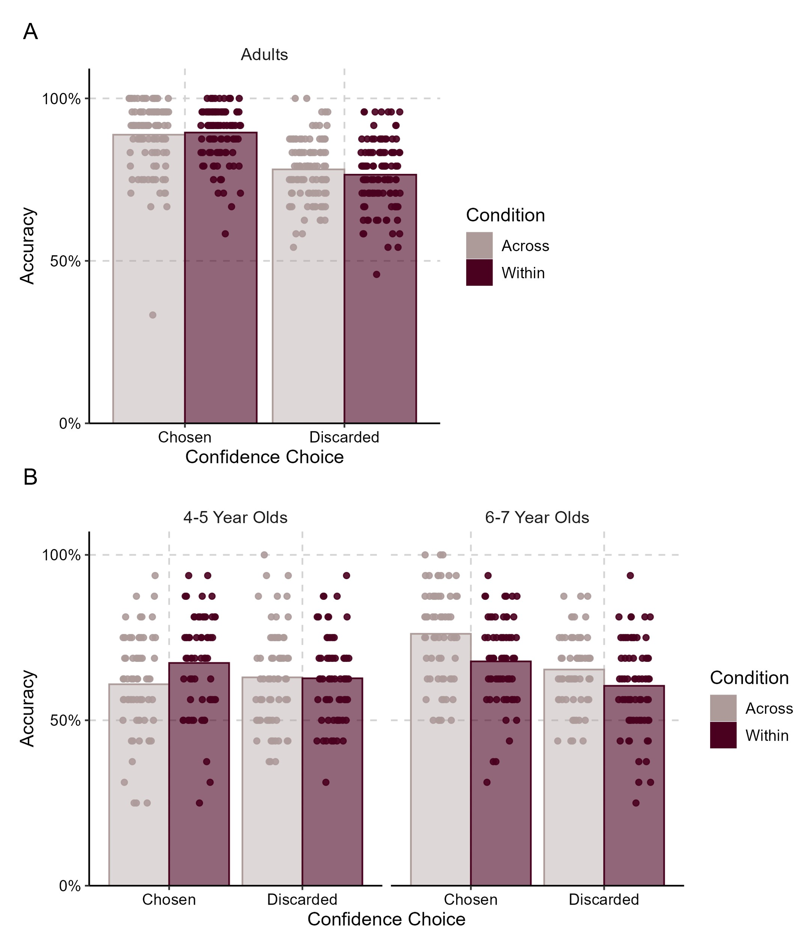
Figure 6. Accuracy as a function of Confidence Choice and Comparison Type.
Perceptual/Memory accuracy as a function of Confidence Choice (Chosen or Discarded) and Comparison Type (Across-Domain or Within-Domain) for (A) adults (N = 107) and (B) children (N = 132). Dots represent individual participants and are randomly jittered for visibility.

Memory/Perception accuracy found adults’ (N = 107) confidence choices reflected their accuracy: Chosen trials were more accurate than Discarded trials, F(1, 106) = 198.64, p < .001, η_{p}² = .65, see Figure 6A. Importantly, this main effect of Confidence Choice was not qualified by an interaction with Comparison Type, F(1, 106) = 2.59, p = .111, η_{p}² = .02, suggesting that Within-Domain Confidence Choice did not show any advantage over Across-Domain Confidence Choice. There was no main effect of Comparison Type, p = .469. An identical Bayesian RM ANOVA found overwhelming evidence for the Confidence main effect, 80% probability given the data, BF₁₀ = 7.813 × 10²². The model including the Confidence by Condition interaction was 9.8 times less likely (8% probability, BF₁₀ = 0.10), providing very strong evidence of no interaction.
Children. A 2 (Confidence Choice: Chosen, Discarded) x 2 (Comparison Type: Within-Domain, Across-Domain) x 2 (Age: Younger [4-5], Older [6-7]) repeated-measures ANOVA on children’s (N =132, M = 5;11 [years;months], range = 4;0 - 7;11, 63 females, 69 males) Memory/Perceptual accuracy found a significant main effect of Confidence Choice, F(1, 130) = 22.65, p = <.001, η_{p}² = .15, see Figure 6B. Thus, consistent with previous work, children’s confidence choices reflected their accuracy: Chosen trials had higher accuracy than Discarded trials. Importantly, the main effect of Confidence Choice was qualified by an interaction with Age and Comparison Type, F(1, 130) = 6.03, p = .015, η_{p}² = .04. The best-fitting model from an analogous RM Bayesian ANOVA included the three-way interaction, BF₁₀ > 20 000 000, 50% probability given the data. We therefore conducted separate repeated measures ANOVAs for Confidence Choice and Comparison Type within each age group.
As shown in Figure 6B, older children responded more accurately on Chosen trials compared to Discarded trials, F(1, 65) = 35.00, p < .001, η_{p}² = .35, and on Across-Domain trials relative to Within-Domain trials, F(1, 65) = 21.10, p < .001, η_{p}² = .25. There was no interaction between Confidence Choice and Comparison Type in older children, F(1, 65) = 1.46, p = .231, η_{p}² = .02. The best-fitting model from an analogous Bayesian RM ANOVA included main effects of Confidence and Condition without an interaction, 70% probability, BF₁₀ > 20 000 000. The model including an interaction term was 2.23 times less likely, with 30% probability, BF₁₀ = 0.44 relative to the best-fitting model. Together this suggests that 6-7-year-olds’ sensitivity in comparing confidence was not different within versus across domains.
Younger children’s accuracy, in contrast, did not differ by Confidence Choice, F(1, 65) = 0.69, p = .411, η_{p}² = .01, or Comparison Type alone, F(1,65) = 3.87, p = .053, η_{p}² = .056. Instead, there was a Confidence Choice by Comparison Type interaction, F(1, 65) = 4.97, p = .029, η_{p}² = .07. Younger children did not appear to compare their confidence across domains, as accuracy did not differ by Confidence Choice on Across-Domain trials, paired t(65) = -0.87, two-tailed, p = .388, d = 0.14. They could, however, compare their confidence within domains, as accuracy was higher on Chosen Within-Domain trials than Discarded ones, paired t(65) = 2.45, two-tailed, p = .017, d = 0.33. No models from an analogous Bayesian RM ANOVA outperformed the null model, which had 38% probability. The model including an interaction was 1.88 times less likely, with 20% probability, BF₁₀ = 0.53. Due to the inconsistency between frequentist and Bayesian results, we caution against strongly interpreting 4-5-year-old children’s results as evidence for or against the domain-general view.

General Discussion
Confidence is a valuable signal about the reliability of our thoughts, but the mechanisms supporting its computation across disparate cognitive domains remain a puzzle. Most of our knowledge on the topic comes from correlational studies with adult participants, which do not enable the investigation of other domain-general signals like commensurability or the possibility of developmental change. Here, we built on emerging evidence that estimating confidence is broadly dependent on at least three steps: individuals must identify relevant signals to estimate confidence, they must represent it on a scale in some internal unit, and then they must convert it to whatever scale the task requires of them ^{2,7}. We examined which properties of this confidence process are shared across perceptual and memory decisions in children aged 4-7 and in adults. Broadly, we find distinct patterns for each step in the confidence computation process: adults and children use distinct signals for memory and perception decisions, but place these signals on easily comparable scales, and are subject to similar biases when reporting on their confidence; we also find few developmental differences in these patterns, at least between the ages of 6 and adulthood.
In Experiment 1, we found correlated individual differences for confidence bias between perception and memory judgments in both children and adults: people who were miscalibrated in one domain tend to be similarly miscalibrated in the other domain. This suggests that the conversion from internal units to external scales is similar across domains. We did not, however, find correlated individual differences in confidence sensitivity (meta-d’) or metacognitive efficiency (MRatio) in either children or adults, suggesting that the signals children and adults use to estimate confidence are distinct for these domains. For example, perceptual confidence may be based on estimates of inherent noise in the perceptual representations ^{5,6} while memory confidence may be based on the fluency of recall ^{42,43}. In Experiment 2, we found that children aged 6 and 7 years and adults could compare their confidence across memory and perceptual decisions without a cost to accuracy, a sign of commensurability and shared internal units. Our findings are consistent with the possibility that, from at least age 6 onward, signals for perceptual and memory confidence remain distinct and independent, but can be converted into a common abstract scale that permits for easy comparison across domains. This scale is then externalized given task demands, and biases in this process are similar for memory and perception across development.
Interestingly, we did not conclusively find that children at 4-5-years of age could flexibly compare their confidence across domains. One possibility is that the common abstract scale of confidence emerges in early childhood, as children learn how to combine signals for each domain. The ability to convert the domain-specific certainty signal into a standardized metric might emerge or improve as children develop. An alternative possibility is that young children have a strong bias to believe that one of the domains is superior to the other, persistently choosing it in the cross-domain condition, lowering their accuracy. Consistent with this, we find that the majority of mistakes young children made in the cross-domain condition stem from them choosing memory decisions even when they were incorrect. Another alternative possibility is that these younger children did not have sufficient metacognitive abilities to demonstrate competency on this task. Five-year-olds exhibited reliable metacognitive sensitivity in Experiment 1, and the frequentist analyses show that 4-5-year-olds demonstrated an ability to accurately compare their confidence within a single domain in Experiment 2, but the Bayesian analyses do not confirm this pattern. Finally, although Experiment 2 did not require any conversion to a response, participants might have done so implicitly before comparing, and therefore any lack of commensurability might be due to 4-year-olds experiencing difficulty with this process. The current task therefore cannot adjudicate between these possibilities, and we leave it as an avenue for future research.
The correlational patterns in Experiment 1 are largely consistent with other findings in the literature, and we extend them developmentally. Metacognitive sensitivity and efficiency in episodic memory and visual perception have previously been shown to have the weakest correlations in adults ¹⁷, but metacognitive bias is usually correlated across these domains ^{44,45}. Similarly, most metacognitive domains do not correlate in childhood ^{34,36}, and our findings extend this pattern to visual perception and episodic memory. Because metacognitive sensitivity is a measure of how well observers attend to the inherent uncertainty of their representations, the lack of correlation suggests that children and adults do not use or attend to uncertainty for memory and perception in the same way. An observer skilled at generating perceptual confidence from sensory noise may not be similarly skilled at generating memory confidence from fluency. Relatedly, children discover the informativeness of distinct inputs for confidence judgments at different ages ⁴⁶. Domain-specificity of confidence judgments in childhood might result from children relying on a limited number of [domain-specific] inputs, but domain-generality could emerge as they uncover new [domain-general] inputs as they develop.
On the flip side, we find that metacognitive bias is strongly correlated across ages and domains. Metacognitive bias is importantly separable from sensitivity: one can have sharp access to the amount of sensory noise, but still consistently (mis)believe that their confidence does not qualify as very high because of stable factors like self-efficacy ^{3,47}. Our results extend previous correlations between perceptual and memory metacognitive bias in adults and demonstrate that they are equivalently present in children. Therefore, whatever process ultimately converts internal confidence to an external scale appears to be similar and manifested in individual differences. The correlation in bias also suggests that any correlational work that does not separate sensitivity from bias might conclude that children’s confidence sensitivity is correlated across domains, when only their bias might be.
While much of the classic work on metacognition has argued for a two-step process – internal uncertainty signals simply converted to an external scale – more recent work has shown that there must be some kind of an intermediate step in which uncertainty is mapped to a mental confidence scale with confidence units (e.g., probability or self-consistency)^{2,7}. This follows from models that suggest that confidence is a grouping of multiple lower-level cues – e.g., memory familiarity and retrieval fluency and one’s beliefs about how good their memory is, etc. ⁴⁸, which must then be combined into an internal estimate on an abstract scale. If this scale is distinct for different domains, comparison of confidence states should be costly, while a common scale would permit for efficient comparison across domains. Our results in Experiment 2 suggest that from age 6 onward, confidence for memory and perception is represented on either an identical internal scale or on scales so easily translatable that comparison does not invoke a cost to accuracy. Therefore, while the underlying information for memory and perceptual confidence appears distinct, our data suggest these signals can be mapped onto a comparable scale. We conducted our studies in the domain of visual perception and visual memory to ensure that potential differences in metacognitive functioning did not stem from coarse differences in the type of stimuli. However, future work should test for a comparable scale in other domains, sensory modalities, and formats.
There are some limitations to this work. Our preregistered exclusion criteria led to about 20% of adults and 40% of children (especially 4-year-olds) being removed from the analysis in Experiment 1. Our results may therefore over-represent people with stronger attention or working memory ability or motivation to complete the task, though our robustness tests found nearly identical results with reduced exclusion criteria (see Robustness Tests in the Supplemental Information). With respect to our commensurability question, we did not measure reaction times or other types of costs, which limits our ability to draw firm conclusions as to whether confidence is represented on an identical internal scale or on scales that are easily translatable. Future research should focus on collecting additional indices to provide a more comprehensive assessment of potential costs of task comparisons. We also found a discrepancy between the frequentist and Bayesian results for 4-5-year-olds in Experiment 2, which limits our ability to make strong claims about the trajectory of a common scale in these ages. Strong claims about age trajectories are also constrained by differences accuracy levels and in memory stimuli (colour identification in children and state identification in adults). However, while these task differences might offer some commonalities through shared colour reasoning, we do not observe higher correlations in children’s metacognitive indices relative to adults, suggesting minimal influence on our results.
Our work helps reconcile previously contradictory findings in the literature by showing that some aspects of confidence representations are domain-specific, while others are domain-general, and that this pattern largely holds across development. The results of this study have potential implications for how to interpret and promote metacognitive awareness, an important consideration given the documented importance of metacognitive skills for academic achievement ^{49,50}. The absence of a correlation between metacognitive sensitivity across cognitive domains suggests that educators should resist drawing inferences about children’s metacognitive skills based on abilities shown in a particular domain. Conversely, training metacognitive sensitivity in one domain to recognize mistakes or devote more efforts to learning likely will nor transfer across domains. Investigations into whether and how developmental change occurs in the process of generating confidence remains a fruitful avenue for our understanding of metacognitive confidence judgments.

Methods
All preregistrations, materials, data, and analyses can be found on https://osf.io/hf6xj/. All studies were approved by the University of British Columbia’s Behavioural Research Ethics Board under projects “The Psychophysics of Quantity, Language, and Internal Confidence” (H14-01968) and “Development of Quantity and Language” (H14-01984). Adults provided consent for themselves, and children participated only if their parents or legal guardians provided written consent. Adults received course credit, and children received a sticker and a certificate.

Experiments 1A (Adults) and 1B (Children)

Participants
We recruited 163 undergraduate students at a large North American university in an on-campus lab and 216 children ages 5 through 7 years at local schools and daycares and online from a local participant database. This age group for children was chosen because of previous work showing some developmental changes in confidence domain-generality between 5 and 8 years of age ^{36,38}, and to provide data on memory and perceptual confidence domain-generality in a younger age group than previously studied. Participants generally came from middle-class White and East/Southeast Asian backgrounds, representative of the city where testing took place.
Following our preregistered plans (https://osf.io/yq73r/ and https://osf.io/9gsnq from November 2019), we excluded participants who completed insufficient trials on either task (quantified as 100% for children: 15 for memory, 18 for perceptual, or 80% for adults: 2 for memory, 5 for perceptual), who did not understand the memory or perceptual task (quantified as accuracy below 55% for children: 44 for memory, 24 for perceptual; or failing a binomial test for adults: 21 for memory, 4 for perceptual), who had no variability in their confidence judgments (3 children for memory, 8 children for perceptual), or who heard English less than 50% of the time (2 children). We intended to include 4-year-olds, but had to exclude 17 of 19 of 4-year-old children tested based on these criteria. We therefore excluded all 4-year-olds and increased our sample of 5-7-year-olds. We conducted a robustness test of our results by including any participant who completed the study, and found the same patterns of correlations as reported in the Results (see Robustness Tests in the Supplemental Information; all data and code are available on OSF). The only different results were significant main effects and interactions of Age and Accuracy in the ANOVA on children’s confidence ratings, driven by a lack of difference in confidence ratings between accurate and inaccurate trials for 4-year-olds.
Our final samples included 129 adults and 131 children (M_{age} = 6;7 [years;months], range = 5;1 - 7;11, 59 girls, 72 boys) with data in both tasks, meeting our target sample sizes based on preregistered power analyses using PANGEA (https://jakewestfall.shinyapps.io/pangea/). Sample sizes were powered to detect a correlation of ρ = .28 (α = .05, power = .90), based on prior findings ¹⁷.

Materials and Procedures
We administered an episodic memory and a perceptual confidence task as they are well-studied in adults and easy to adapt for children ^{16,17,38,40,51}. Participants completed the two tasks on a computer using MATLAB (2019A) ⁵² in a counterbalanced order. Adults entered their own responses through key presses; children’s responses were entered by an experimenter. Both tasks were designed to yield approximately equivalent accuracy at the group level.
Episodic Memory Task. Participants were shown a series of images, then were asked to recognize those images when paired with similar competitors. Trials were presented in a random order and no feedback was given about accuracy. The encoding phase immediately preceded retrieval, regardless of counterbalancing with the perceptual task.
Adults. Adults saw colour photographs of 100 test objects and 100 distractors objects in a specific state for 1000 msec at encoding (e.g., open or closed, see Figure 2), and needed to identify the correct state at test ⁵³.
Children. Children saw drawings of 32 test objects, 14 distractors and 3 training images (always presented first) recoloured into either blue or yellow at encoding, and needed to identify the correct colour at test ⁵⁴ (see Figure 2). The number of trials had to be lower for children compared to adults to prevent performance declines due to fatigue. Stimuli differences were the result of piloting different stimulus sets with adults to try and achieve approximately 75% accuracy, which ensures strong levels of performance while providing enough incorrect trials for performance estimates of metacognitive ability. These were presented for 2000 msec for 5-year-olds or 1500 msec for 6-7-year-olds, and we ensured that they attended the relevant information by asking children to name the object and its colour (e.g., “a blue fox”).
At retrieval, children saw the target items one at a time and identified whether they saw the yellow or blue version (see Figure 2). The 32 test trials were supplemented with 4 ‘Impossible’ trials with items they had never seen before to ensure some incorrect trials.
Perception Task. Participants indicated which of two amorphous shapes was bigger (see Figure 2). Shapes always appeared on separate sides of the screen in different colours. Trials were presented in a random order and no feedback was given about accuracy.
Adults. Adults saw 100 trials with a 1.1 ratio of pixels (e.g., 24750 vs 22500) that should lead to 85% accuracy on average, to match the expected accuracy on the memory task ^{53,55}. Images did not disappear.
Children. We presented children with 4 similar ratios of pixels that should lead to 65-75% accuracy in these age groups ⁵⁵. For 5-year-olds, these ratios were 1.2 (e.g., 22500 vs 18750 pixels), 1.17, 1.14, and 1.1. For 6-7-year-olds, they were 1.1, 1.08, 1.05, and 1.03. The trial disappeared after 2000 msec (for 5-year-olds) or 1500 msec (for 6-7-year-olds) to encourage children to answer promptly. As with the Memory task, there were 32 target trials supplemented by 4 ‘Impossible’ trials (where the two shapes had the same number of pixels).
Metacognitive Judgments. Following each trial of both the Memory and Perceptual tasks, participants made a metacognitive assessment of their confidence using a 3-point scale. For adults, each level of confidence was represented with a number: 1 for “not at all confident”, 2 for “somewhat confident”, and 3 for "very confident”. For children, each level of confidence was represented in the scale by an image of a gender-neutral child demonstrating a facial and body expression associated with high, moderate, and low confidence ⁴⁰ (see Figure 2).
Training (Children only). Children completed 5 training trials immediately before completing the test trials in both the Memory and Perceptual tasks to ensure they understood the scale. The experimenter told children to use the “really sure” face when they definitely knew the answer or didn’t have to think at all, to use the “kind-of sure” face when they maybe knew the answer or had to think about it a little bit, and the “not so sure” face when they didn’t know the answer or had to think really hard about it. Children then went through the practice trials with corrective feedback from the experimenter based on the child’s displayed confidence when answering the question (e.g., “It seemed like you were really sure about that one, so you should have picked the really sure face”) ⁵⁶. To help elicit feelings of confidence from the entire scale range, three practice trials were easy (relying on primacy effects for memory, and using a ratio of 1.5 for perception), and two were impossible.

Analyses
Individual differences in confidence judgements were measured via the field-standard meta-d’ framework ⁵⁷. Although alternative measures exist, recent reviews conclude that this framework continues to perform as well or better than other measures across most dimensions ⁵⁸. As extensively discussed elsewhere ^{41,57,59}, confidence judgments reflect 3 separate signals: metacognitive sensitivity (the ability to differentiate confidence), metacognitive bias (preference for high or low confidence), and task abilities (e.g., episodic memory and area perception). We used the standard meta-d’ toolkit ⁵⁷ to estimate metacognitive sensitivity (meta-d’) and metacognitive efficiency (MRatio), applying standard edge-correction (1/6) to eliminate 0 counts which disrupt the model. MRatio is a measure of how much information about the decision was available to the metacognitive system relative to how much information was involved in making the decision (e.g., task performance). MRatio is optimal at a value of 1 (all information used to make the decision was available to the metacognitive system). Below 1, the MRatio signals a loss of information from the decision to the metacognitive judgment; above 1, the MRatio signals additional information available to the metacognitive decision (e.g., realizing one made a mistake). Together, these two scores tell us how good a participants’ metacognitive abilities are without being influenced by their biases to report high or low confidence, and how good these abilities are relative to their first-order performance. We estimated metacognitive bias by rescaling participants’ average confidence answers to range from 50-100 to match the range of their task accuracy, then subtracted their average accuracy (thus accounting for variability in task performance). We also report meta-d’ analyses using the H-Meta-d’ toolkit ⁵⁹ in the Supplemental Information (in section ‘HMeta-d’ Modelling). We found major anomalies in the way H-Meta-d’ handled children’s data, potentially consistent with recent evidence that this framework has an increased false positive rate ⁶⁰.
The primary aim of Experiment 1 was to examine if these individual differences in confidence (meta-d’, MRatio, and bias) correlate across memory and perception decisions for adults (Experiment 1A) and children (Experiment 1B). Spearman correlations were used when data violated normality or where preregistered. Bayes factors reported alongside correlations were conducted in JASP (0.19.2). ⁶¹ with default priors. As JASP does not have Bayesian Spearman correlations, Kendall’s tau was used instead. All analyses are two-tailed. Our analysis plan was preregistered on OSF (https://osf.io/yq73r, https://osf.io/9gsnq); any additional analyses are noted as exploratory.

Experiments 2A (Adults) and 2B (Children)

Participants
We recruited 175 undergraduate students and 137 children aged 4-7 years from the same population as Experiments 1A and 1B. Following our preregistered plans (https://osf.io/y4hdt from February 2021 and https://osf.io/2gx3z from September 2020), we excluded participants who failed to complete the entire task (3 children), who did not understand the memory or perceptual task (quantified as failing a binomial test for adults: 52 for Perception, 50 for Memory; we did not preregister this criteria for children), who heard English less than 50% of the time (1 child), or who had a parent or teacher-reported developmental disorder (1 child). Our final samples therefore included 107 adults and 132 children (M = 5;11 [years;months], range = 4;0 - 7;11, 63 girls, 69 boys), meeting our target sample sizes based on preregistered power analyses using PANGEA (https://jakewestfall.shinyapps.io/pangea/). Sample sizes were powered to detect the interaction between Accuracy and Domain for an effect size of η_{p}² = .01 (α = .05, power = .90).

Materials and Procedures
Stimuli were presented on the computer, as in Experiment 1, through MATLAB (2019A) ⁵² for children and PsychoPy (2021.1)⁶² for adults. On each trial, participants saw two discrimination decisions taken from Experiment 1, one easy and one hard, presented in different spatial locations on the screen. After answering both questions, participants provided a retrospective relative confidence judgment: indicating which of the two answers they were more confident in. Importantly, this paradigm does not dichotomize confidence into ‘high’ versus ‘low.’ Instead, it requires participants to compare two confidence states and select the one they believe is stronger. If confidence were represented on non-comparable scales across domains, participants would perform at chance in across-domain trials. Accurate performance therefore provides a direct test of whether confidence states are commensurable.
Perception and Memory questions were taken directly from Experiment 1 and specifically chosen to match overall accuracy between the domains. Previous work using the Forced-Choice Confidence measure has found that children’s and adults’ ability to compare relative confidence is best when there is a large difference in accuracy between the two discrimination trials ^{26,39}. Therefore, on half of the trials, each pair of questions had one trial designed to elicit high accuracy and one trial designed to elicit low accuracy, based on item-level analyses from Experiment 1. On the remaining half of trials, questions were paired to elicit the same accuracy, as a more stringent test of whether participants can compare their confidence in the absence of potential item-level difficulty cues.
The experiment began with four practice trials of the Perception task where participants were asked to select the larger of two shapes. Then, participants viewed the same Encoding trials as in Experiment 1.
The main test trials had 2 phases. First, the participants answered a question on the left side of the screen, followed by a question on the right. Then, they were asked “Which of those two answers [they were] more confident they got correct” (or “Which one was your best answer? Which one are you really sure that you got right?” for children, which are both highly intuitive and do not require training). Participants were not given feedback about the accuracy of their answers, though children were given encouraging remarks periodically to keep them motivated (e.g., “You’re going so fast!”, “Alright, let’s do another one!”) ³⁹.
Adults saw 48 confidence trials: 24 Within-Domain (12 for Memory, 12 for Perception) and 24 Across-Domain (Memory vs Perception). Children saw 32 confidence trials: 16 Within-Domain and 16 Across-Domain. Trials appeared in a random order and were counterbalanced to ensure that each domain appeared equally on the left and right side.

Analyses
We examined our predictions through both standard and Bayesian repeated-measures ANOVAs (using default priors in JASP), which allow us to quantify the likelihood of null effects ⁶¹. All tests are two-tailed. Our analysis plans were preregistered on OSF (https://osf.io/y4hdt and https://osf.io/2gx3z).

Data Availability
The data used in these analyses is available on the Open Science Framework at https://osf.io/hf6xj/.

References
1. Baer, C. & Kidd, C. Learning with certainty in childhood. Trends Cogn. Sci. 26, 887–896 (2022).
2. Pouget, A., Drugowitsch, J. & Kepecs, A. Confidence and certainty: distinct probabilistic quantities for different goals. Nat. Neurosci. 19, 366–374 (2016).
3. Fleming, S. M. & Lau, H. C. How to measure metacognition. Front. Hum. Neurosci. 8, 443 (2014).
4. Galvin, S. J., Podd, J. V., Drga, V. & Whitmore, J. Type 2 tasks in the theory of signal detectability: Discrimination between correct and incorrect decisions. Psychon. Bull. Rev. 10, 843–876 (2003).
5. Halberda, J. & Odic, D. The precision and internal confidence of our approximate number thoughts. Evol. Orig. Early Dev. Number Process. 305–333 (2014) doi:10.1016/B978-0-12-420133-0.00012-0.
6. Kiani, R. & Shadlen, M. N. Representation of confidence associated with a decision by neurons in the parietal cortex. Science 324, 759–764 (2009).
7. Caziot, B. & Mamassian, P. Perceptual confidence judgments reflect self-consistency. J. Vis. 21, 8 (2021).
8. Alais, D. & Burr, D. The ventriloquist effect results from near-optimal bimodal integration. Curr. Biol. 14, 257–262 (2004).
9. Mamassian, P. Confidence Forced-Choice and Other Metaperceptual Tasks. Perception 49, 616–635 (2020).
10. Pierce, C. S. & Jastrow, J. On small differences in sensation. Mem. Natl. Acad. Sci. 3, 77–83 (1884).
11. Nelson, T. O. & Narens, L. Metamemory: A theoretical framework and new findings. Psychol. Learn. Motiv. 26, 125–173 (1990).
12. De Martino, B., Fleming, S. M., Garrett, N. & Dolan, R. J. Confidence in value-based choice. Nat. Neurosci. 16, 105–110 (2013).
13. Lehmann, M., Hagen, J. & Ettinger, U. Unity and diversity of metacognition. J. Exp. Psychol. Gen. 151, 2396–2417 (2022).
14. Mazancieux, A. et al. Towards a common conceptual space for metacognition in perception and memory. Nat. Rev. Psychol. 1–16 (2023) doi:10.1038/s44159-023-00245-1.
15. Hart, J. T. Memory and the feeling-of-knowing experience. J. Educ. Psychol. 56, 208–216 (1965).
16. Lund, A. E., Corrêa, C. M. C., Fardo, F., Fleming, S. M. & Allen, M. G. Domain generality in metacognitive ability: A confirmatory study across visual perception, episodic memory, and semantic memory. J. Exp. Psychol. Learn. Mem. Cogn. 51, 1594–1605 (2025).
17. Mazancieux, A., Fleming, S. M., Souchay, C. & Moulin, C. J. A. Is there a G factor for metacognition? Correlations in retrospective metacognitive sensitivity across tasks. J. Exp. Psychol. Gen. 149, 1788–1799 (2020).
18. Mazancieux, A., Hat, K., Rutiku, R., Wierzchoń, M. & Sandberg, K. Confidence in decision making across domains and modalities: evidence from three studies. Preprint at https://doi.org/10.31219/osf.io/v6psx (2024).
19. Rouault, M., McWilliams, A., Allen, M. G. & Fleming, S. M. Human metacognition across domains: insights from individual differences and neuroimaging. Personal. Neurosci. 1, e17 (2018).
20. Kruger, J. & Dunning, D. Unskilled and unaware of it: how difficulties in recognizing one’s own incompetence lead to inflated self-assessments. J. Pers. Soc. Psychol. 77, 1121–1134 (1999).
21. Song, C. et al. Relating inter-individual differences in metacognitive performance on different perceptual tasks. Conscious. Cogn. 20, 1787–1792 (2011).
22. van Loon, M., Orth, U. & Roebers, C. The structure of metacognition in middle childhood: Evidence for a unitary metacognition-for-memory factor. J. Exp. Child Psychol. 241, 105857 (2024).
23. Fleming, S. M., Ryu, J., Golfinos, J. G. & Blackmon, K. E. Domain-specific impairment in metacognitive accuracy following anterior prefrontal lesions. Brain 137, 2811–2822 (2014).
24. Vaccaro, A. G. & Fleming, S. M. Thinking about thinking: A coordinate-based meta-analysis of neuroimaging studies of metacognitive judgements. Brain Neurosci. Adv. 2, 2398212818810591 (2018).
25. De Gardelle, V., Le Corre, F. & Mamassian, P. Confidence as a common currency between vision and audition. PloS One 11, e0147901 (2016).
26. De Gardelle, V. & Mamassian, P. Does confidence use a common currency across two visual tasks? Psychol. Sci. 25, 1286–1288 (2014).
27. Barthelmé, S. & Mamassian, P. Flexible mechanisms underlie the evaluation of visual confidence. Proc. Natl. Acad. Sci. 107, 20834–20839 (2010).
28. Klever, L., Beyvers, M. C., Fiehler, K., Mamassian, P. & Billino, J. Cross-modal metacognition: Visual and tactile confidence share a common scale. J. Vis. 23, 3 (2023).
29. Horn, J. L. Organization of abilities and the development of intelligence. Psychol. Rev. 75, 242–259 (1968).
30. Simpson-Kent, I. L. et al. Neurocognitive reorganization between crystallized intelligence, fluid intelligence and white matter microstructure in two age-heterogeneous developmental cohorts. Dev. Cogn. Neurosci. 41, 100743 (2020).
31. Feigenson, L., Dehaene, S. & Spelke, E. Core systems of number. Trends Cogn. Sci. 8, 307–314 (2004).
32. Baer, C., Malik, P. & Odic, D. Are children’s judgments of another’s accuracy linked to their metacognitive confidence judgments? Metacognition Learn. 16, 485–516 (2021).
33. Bellon, E., Fias, W. & Smedt, B. D. Metacognition across domains: Is the association between arithmetic and metacognitive monitoring domain-specific? PLOS ONE 15, e0229932 (2020).
34. Geurten, M., Meulemans, T. & Lemaire, P. From domain-specific to domain-general? The developmental path of metacognition for strategy selection. Cogn. Dev. 48, 62–81 (2018).
35. Taouki, I., Lallier, M. & Soto, D. The role of metacognition in monitoring performance and regulating learning in early readers. Metacognition Learn. 17, 921–948 (2022).
36. Vo, V. A., Li, R., Kornell, N., Pouget, A. & Cantlon, J. F. Young children bet on their numerical skills metacognition in the numerical domain. Psychol. Sci. 25, 1712–1721 (2014).
37. Baer, C. & Odic, D. Children flexibly compare their confidence within and across perceptual domains. Dev. Psychol. 56, 2095–2101 (2020).
38. Baer, C., Gill, I. K. & Odic, D. A domain-general sense of confidence in children. Open Mind Discov. Cogn. Sci. 2, 86–96 (2018).
39. Baer, C. & Odic, D. Certainty in numerical judgments develops independently of the Approximate Number System. Cogn. Dev. 52, 100817 (2019).
40. Hembacher, E. & Ghetti, S. Don’t look at my answer: subjective uncertainty underlies preschoolers’ exclusion of their least accurate memories. Psychol. Sci. 25, 1768–1776 (2014).
41. Maniscalco, B. & Lau, H. Signal Detection Theory analysis of Type 1 and Type 2 data: Meta-d′, response-specific Meta-d′, and the Unequal Variance SDT model. in The Cognitive Neuroscience of Metacognition 25–66 (Springer, 2014). doi:10.1007/978-3-642-45190-4_3.
42. Kelley, C. M. . & Lindsay, D. S. Remembering Mistaken for Knowing: Ease of Retrieval as a Basis for Confidence in Answers to General Knowledge Questions. J. Mem. Lang. 32, 1–24 (1993).
43. Koriat, A. & Levy-Sadot, R. The combined contributions of the cue-familiarity and accessibility heuristics to feelings of knowing. J. Exp. Psychol. Learn. Mem. Cogn. 27, 34–53 (2001).
44. Ais, J., Zylberberg, A., Barttfeld, P. & Sigman, M. Individual consistency in the accuracy and distribution of confidence judgments. Cognition 146, 377–386 (2016).
45. Lee, A. L. F., Ruby, E., Giles, N. & Lau, H. Cross-domain association in metacognitive efficiency depends on first-order task types. Front. Psychol. 9, 2464 (2018).
46. Roebers, C. M., Mayer, B., Steiner, M., Bayard, N. S. & Van Loon, M. H. The role of children’s metacognitive experiences for cue utilization and monitoring accuracy: A longitudinal study. Dev. Psychol. 55, 2077–2089 (2019).
47. Green, D. M. & Swets, J. A. Signal Detection Theory and Psychophysics. (Wiley & Sons, Inc., 1966).
48. Koriat, A. The self-consistency model of subjective confidence. Psychol. Rev. 119, 80–113 (2012).
49. He, G., Chen, S., Lin, H. & Su, A. The association between initial metacognition and subsequent academic achievement: a meta-analysis of longitudinal studies. Educ. Psychol. Rev. 36, 81 (2024).
50. Ohtani, K. & Hisasaka, T. Beyond intelligence: a meta-analytic review of the relationship among metacognition, intelligence, and academic performance. Metacognition Learn. 13, 179–212 (2018).
51. McWilliams, A., Bibby, H., Steinbeis, N., David, A. S. & Fleming, S. M. Age-related decreases in global metacognition are independent of local metacognition and task performance. Cognition 235, 105389 (2023).
52. The Math Works Inc. MATLAB. The Math Works Inc. (2019).
53. Brady, T. F., Konkle, T., Alvarez, G. A. & Oliva, A. Real-world objects are not represented as bound units: Independent forgetting of different object details from visual memory. J. Exp. Psychol. Gen. 142, 791–808 (2013).
54. Rossion, G. & Poutois, B. Revisiting Snodgrass and Vanderwart’s Object Pictorial Set: The Role of Surface Detail in Basic-Level Object Recognition - Bruno Rossion, Gilles Pourtois, 2004. Perception 33, 217–236 (2004).
55. Odic, D. Children’s intuitive sense of number develops independently of their perception of area, density, length, and time. Dev. Sci. 21, e12533 (2018).
56. Lyons, K. E. & Ghetti, S. I don’t want to pick! Introspection on uncertainty supports early strategic behavior. Child Dev. 84, 726–736 (2013).
57. Maniscalco, B. & Lau, H. A signal detection theoretic approach for estimating metacognitive sensitivity from confidence ratings. Conscious. Cogn. 21, 422–430 (2012).
58. Rahnev, D. A comprehensive assessment of current methods for measuring metacognition. Nat. Commun. 16, 701 (2025).
59. Fleming, S. M. HMeta-d: hierarchical Bayesian estimation of metacognitive efficiency from confidence ratings. Neurosci. Conscious. 1, nix007 (2017).
60. Rausch, M. & Zehetleitner, M. Evaluating false positive rates of standard and hierarchical measures of metacognitive accuracy. Metacognition Learn. 18, 863–889 (2023).
61. Wagenmakers, E.-J. et al. Bayesian inference for psychology. Part I: Theoretical advantages and practical ramifications. Psychon. Bull. Rev. 25, 35–57 (2018).
62. Peirce, J. et al. PsychoPy2: Experiments in behavior made easy. Behav. Res. Methods 51, 195–203 (2019).

